

Governed Review Responses & Guest Signal Intelligence for Hospitality

"Know What Your Guests Meant. Protect Every Response."

PILOT PROGRAM MANUAL

Your Daily Pilot Workflow

A simple 4-step process – just 10 minutes per day to review and approve responses.

VRYOH streamlines intelligence, you maintain final control. Aim for 24-hour response turnaround.

Step 1: Receive
Get unified reviews from all platforms in one daily email by 8:00 AM.

Step 2: Review
Open your Google Sheet to read each new review and VRYOH's draft response.

Step 3: Approve or Edit
Approve the draft as-is, edit for customization, or mark as 'Not Accepted'.

Step 4: Publish
Paste your finalized response directly onto the original review platform.

What We Need From You — Pilot Expectations

To make the pilot work, we need a small amount of review data, a few minutes of brand context, and a light feedback loop.

Your commitment:

- Brand Voice Discovery questionnaire (30 minutes)
- Weekly 15-minute feedback call
- Approval workflow: review drafts in Google Sheet within 48 hours

What we're testing:

- Draft quality against your brand standards
- Signal detection accuracy
- Intelligence report usefulness for management decisions

What success looks like:

- You see signals you couldn't see before
- Drafts require minimal editing
- Intelligence reports inform at least one operational conversation per week

Understanding your reports

Simple steps how to read and get that best from your daily, weekly and monthly report.

24 Hours Review Summary from all platforms
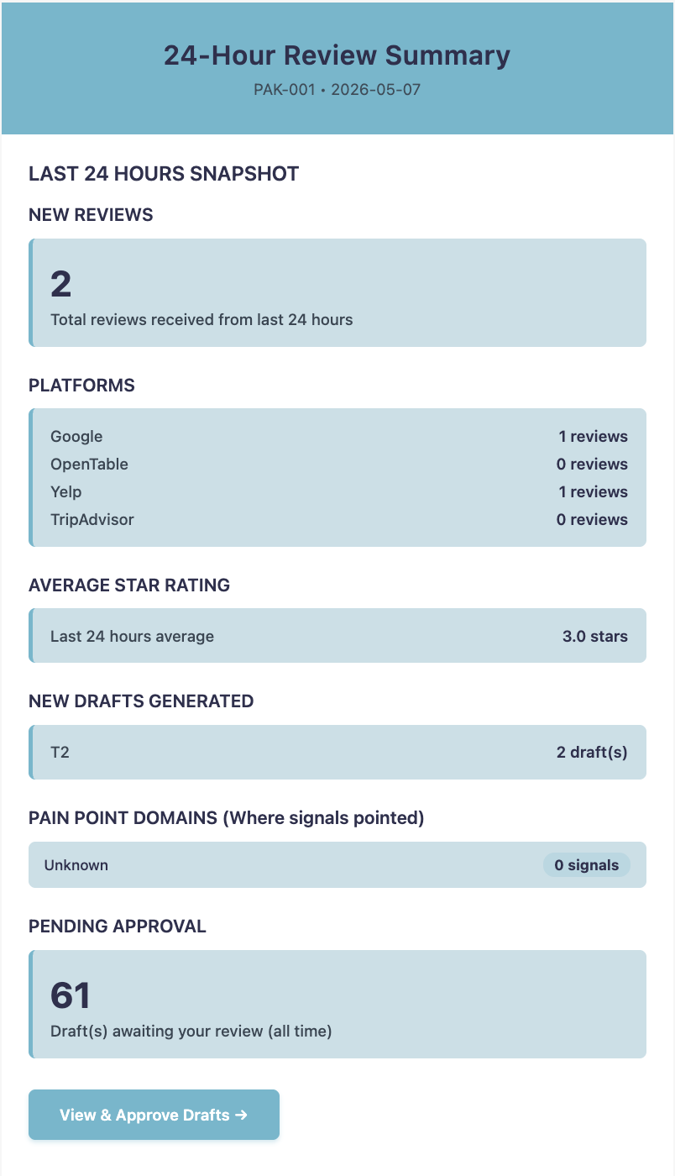
Total count review received 24 hour

Review sources breakdown

Overall guest satisfaction

# of new draft responses for approval

Where friction occurred

# drafts waiting for status

Review text and Propused Reponses (drafts) Google Sheet.

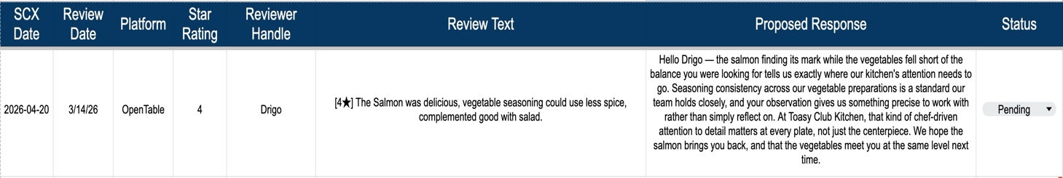

Weekly Intelligence Brief Report from all platforms
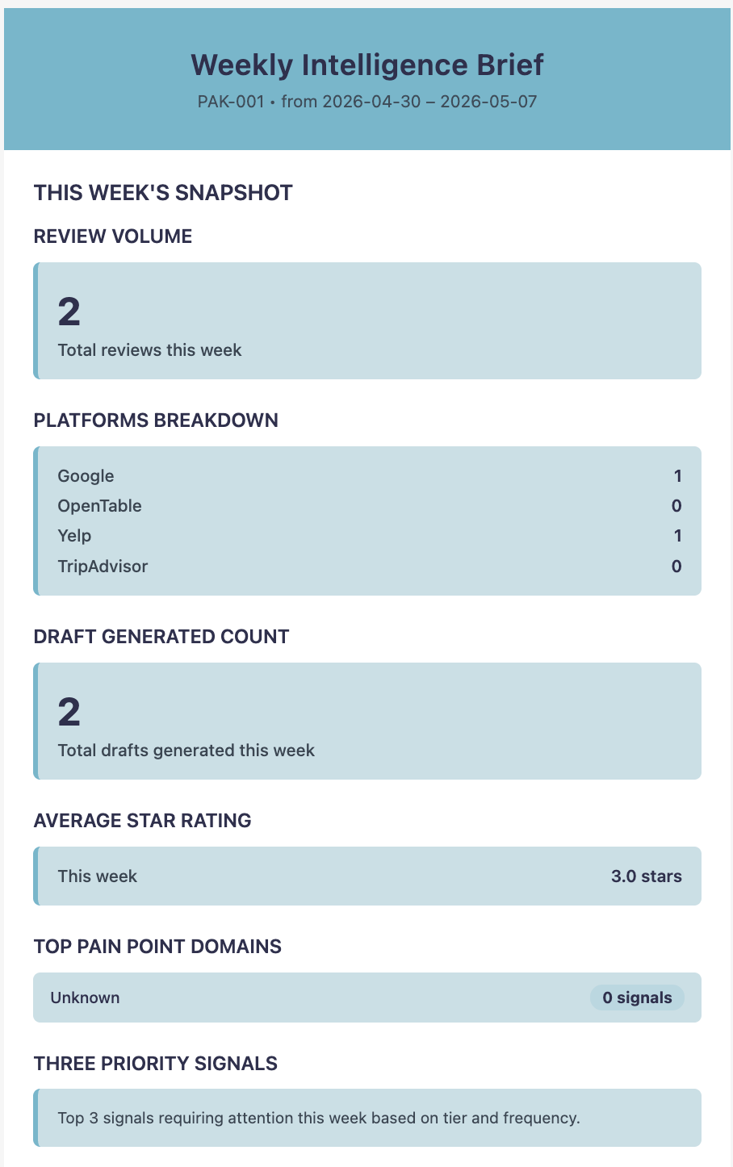
Total count review received 24 hour

Review sources breakdown

# of new draft responses for approval

# of new draft responses for approval

# of new draft responses for approval

# of new draft responses for approval

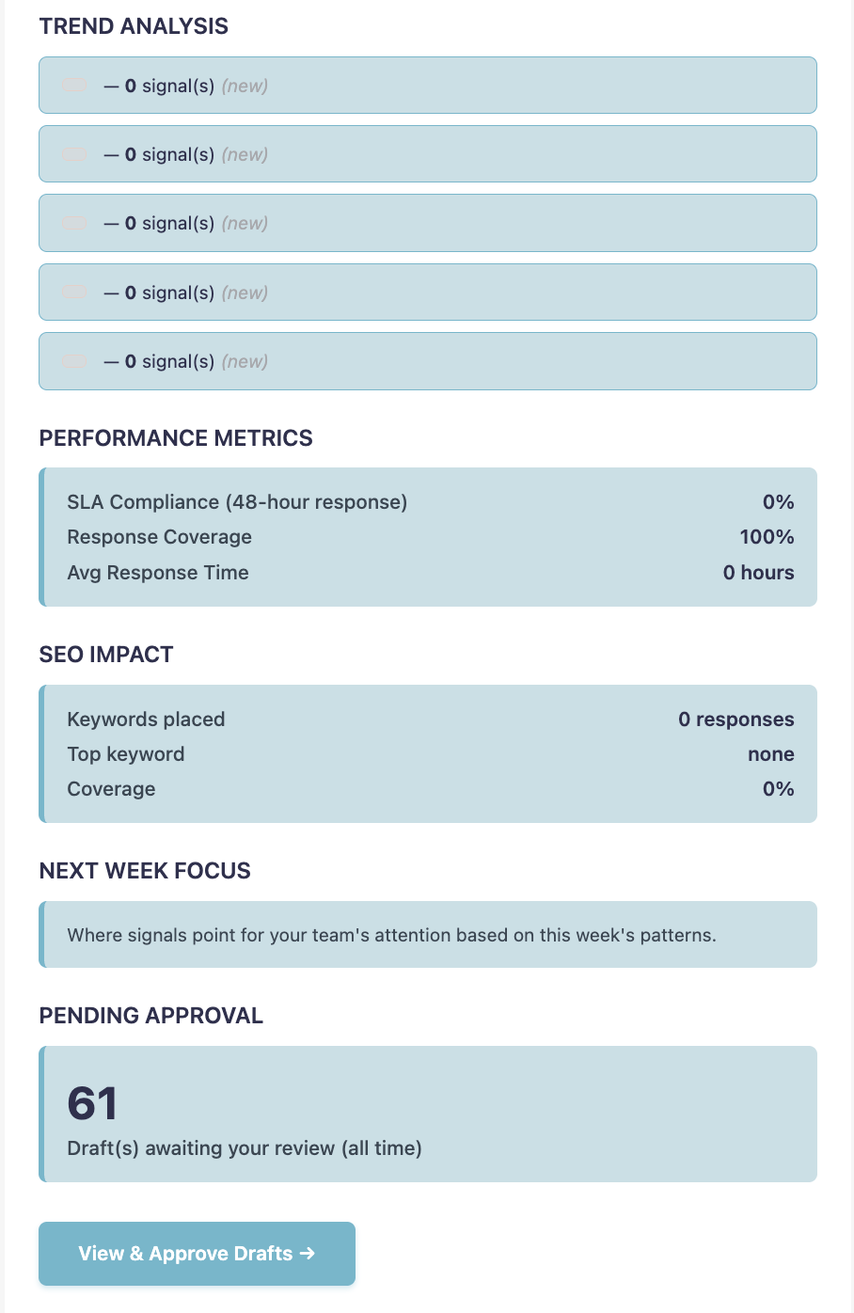
# of new draft responses for approval

# of new draft responses for approval
# of new draft responses for approval
# of new draft responses for approval
# of new draft responses for approval

